ELECTRONIC VOTING MACHINE (EVM) PROJECT REPORT

Project Title: Smart Voting Machine
Course: Digital Logic Design (DLD)
Group Members:
Roshni Vikram(25K0907)
Amna Saad(25k0615)
Syeda Marium Fatima(25k0970)
Instructor: MISS SEEMA HASHWANI
Submission Date: May 10, 2026

ABSTRACT
This project presents the design and implementation of an Electronic Voting Machine (EVM) utilizing fundamental digital logic components. In democratic processes, the integrity of a vote is paramount; even a single miscount can alter election outcomes. This system addresses the need for accuracy and reliability by employing a decade counter for vote tracking, a decoder for visual representation, and a comparator for automated result analysis. The project emphasizes practical electronic principles such as debouncing and signal decoding, moving beyond theoretical concepts to a functional simulation-based prototype.
1. OBJECTIVES
The primary objectives of this Digital Logic Design project are as follows:
- Design Accuracy: To create a 100% logical digital voting system where every button press corresponds precisely to one vote, ensuring zero loss or over-writing of data.
- Practical Implementation: To bridge the gap between theoretical Digital Electronics and practical application by using ICs like decade counters and decoders in a real-world scenario.
- System Verification: To utilize simulation software (Proteus) to verify the circuit's behavior under various test conditions, ensuring the system remains stable and reliable.
- Automated Decision Making: To implement a comparison logic that automatically identifies the leading candidate or a tie situation.

2. INTRODUCTION
Digital logic design is the cornerstone of modern computing and automated systems. An Electronic Voting Machine (EVM) is a critical application of these principles, requiring high precision and security. Traditional voting methods are prone to human error and tampering; a digital approach minimizes these risks by automating the tallying process. This report details the development of an EVM capable of counting votes up to 99 for multiple candidates, featuring real-time visual feedback on a seven-segment display. The system leverages sequential logic for counting and combinational logic for decoding and comparison.
3. PROJECT DESCRIPTION
3.1 Components Used
Component | Functional Role
Decade Counter (e.g., 74HC4017) | Counts pulses from 0-9 and resets; used for tracking vote increments.
Decoder (Common Anode) | Converts binary counter data into active-low signals for the display.
7-Segment Display | Visual interface showing the live vote count for each candidate.
Push Buttons | Input interface for voters to cast their ballots.
5V DC Power Supply | Provides stable voltage required for TTL/CMOS logic operations.
Capacitors & Resistors | Essential for debouncing logic to prevent false triggering.
Comparator IC | Compares the outputs of candidate counters to determine the winner.
3.2 Working Principle
The operational workflow of the EVM is divided into several logical stages:
- Input Stage & Debouncing: When a voter presses a candidate's button, a pulse is generated. To prevent "contact bounce" (where one press is read as multiple pulses), a capacitor and pull-up resistor stabilize the signal, ensuring exactly one pulse per press.
- State Counting: The pulse enters a decade counter. For a two-digit count (up to 99), two counters are cascaded. The first counter handles the 'ones' place, and upon reaching its limit, it triggers the 'tens' place counter.
- Decoding & Display: The binary output of the counters is sent to a decoder. Since a common anode display is used, the decoder outputs low signals to light up the appropriate segments, showing digits 0-9.
- Comparative Logic: The final counts from each candidate's circuitry are fed into a digital comparator. This component evaluates which count is higher and triggers a specific LED to indicate the winner instantly.
3.3 Truth Table / Logic Table
The system logic for counting can be summarized as follows:
Input (Button Press) | Counter State | Display Update
No Press | Stable | No Change
Single Press (Pulse) | Count + 1 | Update Number
Reset (Counter = 9) | 0 | Displays 0

4. PROJECT FLOWCHART
The flowchart would illustrate the path from Push Button Input → Debouncing Logic → Decade Counter → Decoder → Seven-Segment Display & Comparator.
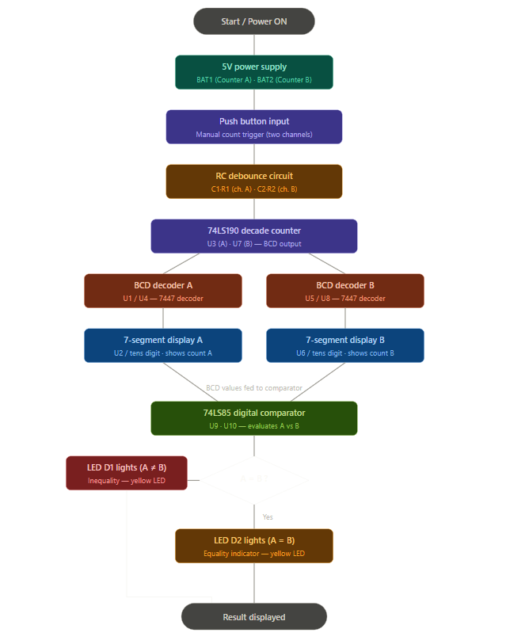
A= B?
5. CIRCUIT DIAGRAM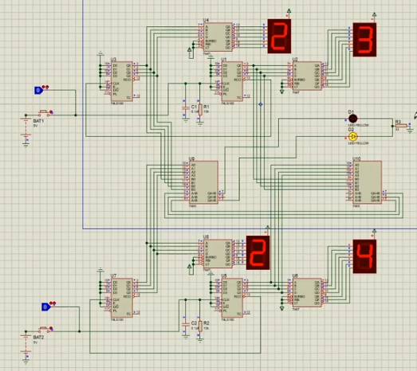
6. IMPLEMENTATION
6.1 Software Implementation
- Tool used: Proteus Simulation.
- Logic design steps: Components such as the 5V supply, counters, and decoders were placed and wired to ensure proper signal flow.
- Simulation steps: Buttons were pressed live during the simulation to verify that the counters incremented correctly, and the comparator identified the winner.

7. TESTING AND RESULTS
Validation was conducted through systematic test cases to ensure logic integrity:
- Test Case 01: Pressing the button for Candidate A. Result: The 'ones' display incremented correctly from 0 to 1.
- Test Case 02: Sustained or rapid pressing. Result: Debouncing logic successfully filtered noise, counting only intentional presses.
- Test Case 03: Full count cycle. Result: Upon the 10th vote, the ones-place reset to 0 and the tens-place incremented to 1.
- Test Case 04: Winning condition. Result: When Candidate A had 5 votes and Candidate B had 3, the comparator correctly highlighted Candidate A as the leader.
8. CHALLENGES AND SOLUTIONS
During the design phase, several technical hurdles were addressed:
- False Triggering: Initial tests showed multiple votes being counted for a single press. This was resolved by adding a RC (Resistor-Capacitor) network for hardware debouncing.
- Signal Logic: Aligning the decoder's output with the common anode display required careful pin configuration to ensure the numbers were not inverted or garbled.
- Cascading Counters Casually: Ensuring the 'tens' digit only moved when the 'ones' digit transitioned from 9 to 0 required precise clock-pulse management between the ICs.

9. CONCLUSION
The Electronic Voting Machine project successfully demonstrated the practical utility of Digital Logic Design. By integrating sequential and combinational logic, we developed a system that is more reliable than manual counting. The project provided deep insights into IC synchronization, display interfacing, and the critical importance of signal conditioning in digital systems. Future iterations could include a "Total Vote" reset lock and an EEPROM for permanent data storage in case of power failure.
10. REFERENCES.
- Digital Logic Design Lab Manuals.

